Circular & Sustainable 3D Printing

Applications
Masters graduation or research project

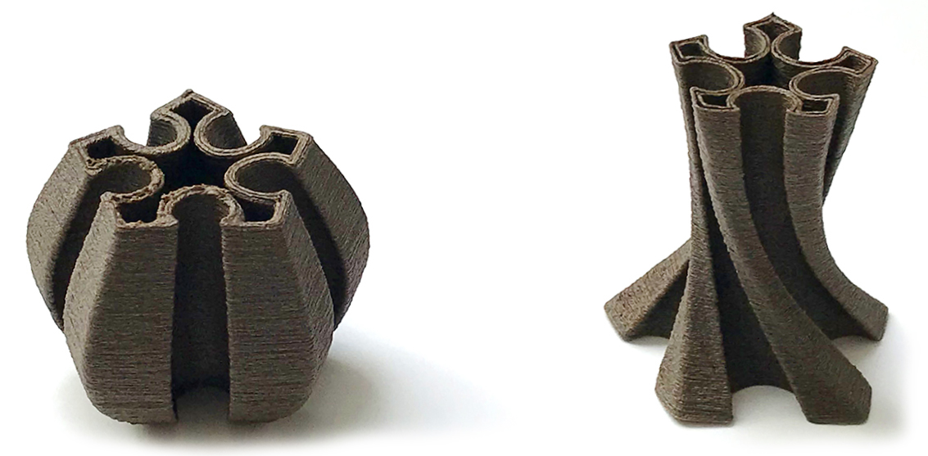

The problem: 3D printed plastic parts often cause much higher environmental impacts per part than traditional injection molding at scale. This is because 3D printing requires much more energy per part than injection molding. However, new materials can enable 3D printing that is actually an environmental improvement instead. Replacing the melting of plastic with the extrusion of pastes that bond chemically at room temperature can use up to 75% less energy than standard ABS extrusion. Furthermore, the embodied impacts of good materials can be 80% lower than ABS plastic, by choosing materials with low toxicity and a circular life cycle (compostable biomaterials, even sourced from agricultural waste like sawdust or the shells of cacao, pecans, or oysters). Such materials can even be half the cost of standard ABS printing filament. However, example use cases must be developed. This assignment allows for a wide range of creativity on behalf of the student in finding new and exciting applications.

Project goal: Use existing material recipes to design, develop and prototype commercial use cases and products with the material. Commercial use cases can range from interior design products to large scale applications. Project variations could include life cycle assessment and/or material toxicity assessment of 3D printed parts versus standard plastic printing.

Company partner: Reflow Filament, https://reflowfilament.com. They are developing material recipes using these biomaterials (not yet shown on their website). Due to the early and innovative stage of the technology the company is looking for example applications of the materials to showcase. They have clay and polymer 3D printers available for use and are willing to spend time with students to print and prototype.

Skills required: Applicants must have strong experience in designing for desktop extrusion printing, and knowledge of G-code. Ideally applications have experience using paste-based extrusion/ clay extrusion and grasshopper path modelling or are willing to spend additional time learning these skills.
Time commitment required is a graduation project or a research project of 9 ECTS.

Contact: Assistant professor Jeremy Faludi, j.faludi@tudelft.nl.

